MOCKITO & SFL4J
Exercise 1:
package com.chief.junit;
import org.junit.jupiter.api.Test;
import static org.mockito.Mockito.*;
import static org.junit.jupiter.api.Assertions.*;
class UserServiceTest {
@Test
void testGetUserName() {
Database mockDb = mock(Database.class);
when(mockDb.fetchNameById(1)).thenReturn("Chief");
UserService userService = new UserService(mockDb);
String name = userService.getUserName(1);
assertEquals("Chief", name);
}
}
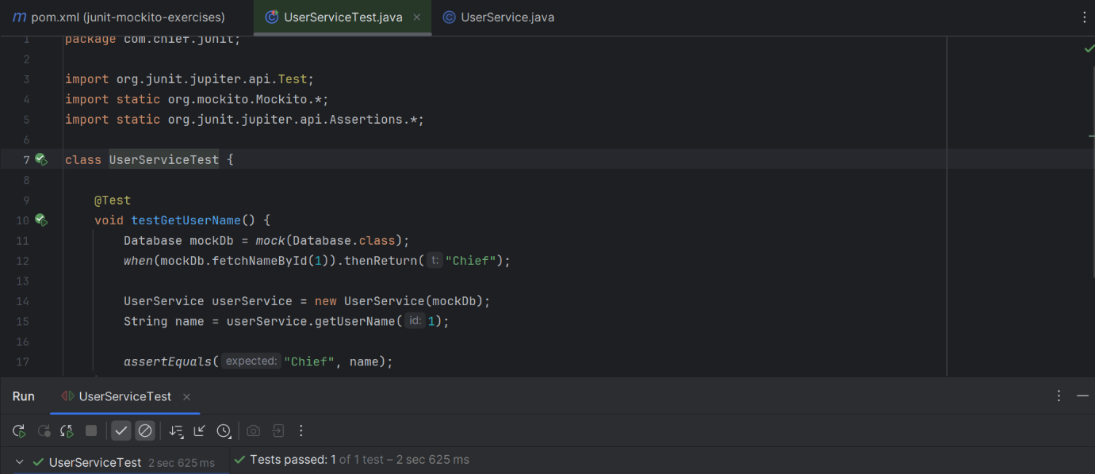
Exercise 2:
package com.chief.junit;
import org.junit.jupiter.api.Test;
import static org.mockito.Mockito.*;
public class InteractionTest {
@Test
void testInteractionWithMock() {
Database mockDb = mock(Database.class);
mockDb.fetchNameById(100);
verify(mockDb, times(1)).fetchNameById(100);
}
}
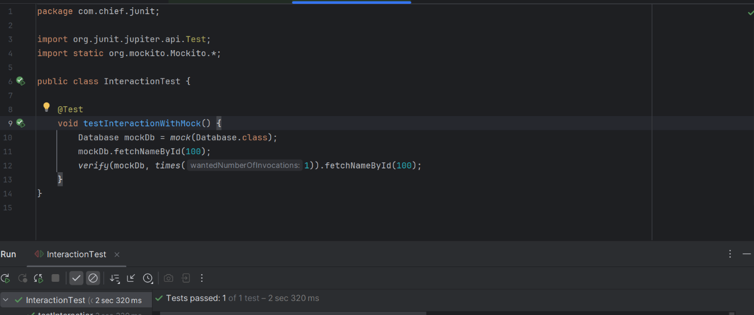

Exercise S LF4J:
package com.chief.junit;
import org.slf4j.Logger;
import org.slf4j.LoggerFactory;
public class LoggingExample {
private static final Logger logger = LoggerFactory.getLogger(LoggingExample.class);
public static void main(String[] args) {
logger.error("❌ This is an error message");
logger.warn("⚠️ This is a warning message");
}
}
